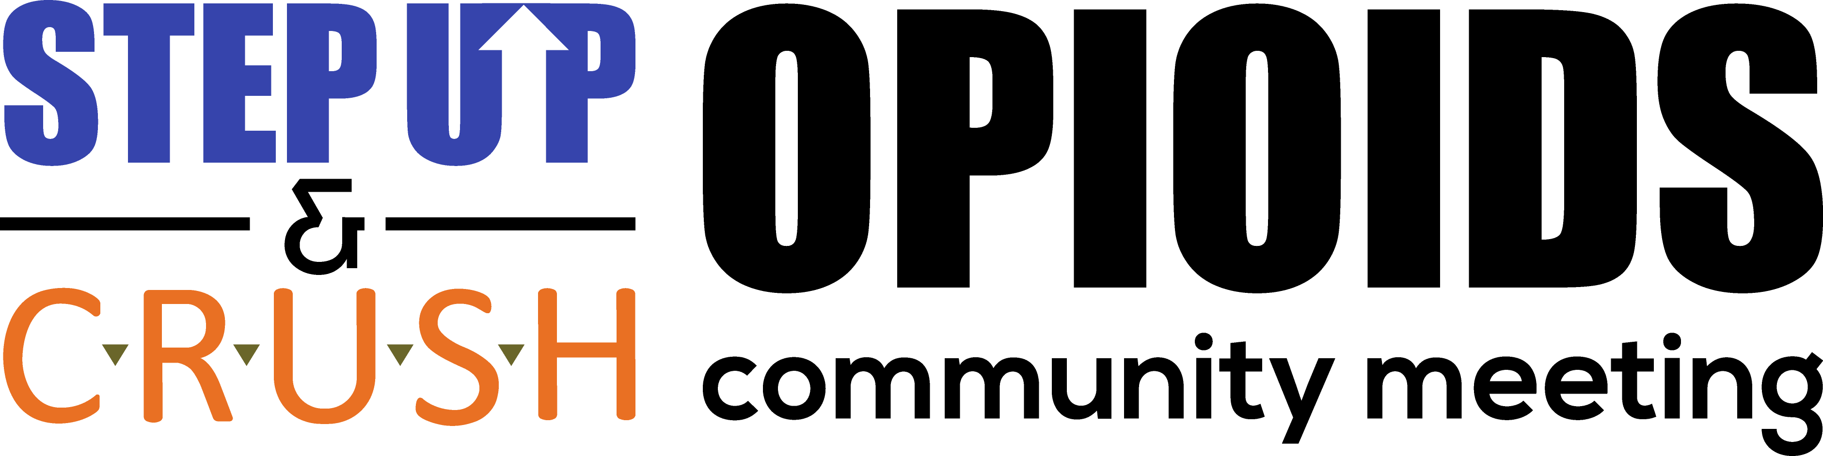

SEPTEMBER 19, 2019

REGISTER AT: www.stepupstl.org/opioidcommunitymeeting/

EVERY COMMUNITY MEMBER AND TEEN INVITED - ALL DISTRICTS/AREAS
Presented in collaboration with the St. Louis County Police Department – Affton/Southwest Precinct, Missouri Department of Corrections, St. Louis CRUSH, Step Up of St. Louis and the St. Louis County Police Department Bureau of Drug Enforcement.
Every effort will be made to provide child care, transportation and translation services.
Schedule of Events:
5:00: Early Packet Pickup for Sept 21 Step Up & CRUSH 5K RUN/WALK (open until 8:30)
5:30: Resource Fair and Teen Resiliency Area Open
6:00: Fentanyl and Opioids Presentation and Panel Discussion Q&A with leading experts in the field: Missouri Institute of Mental Health, Missouri Department of Corrections, Missouri Network for Opiate Reform and Recovery, NCADA, Preferred Family Healthcare, St. Louis Department of Public Health, St. Louis County Police Department.
8:15: Optional Sessions Begin: NARCAN Training, Grief Support, Family Support, Individual Support, Teen Resiliency
Attendance is free – sponsorship and donations are welcome please visit www.stepupstl.org for more information. All proceeds from this and the 5K will be shared by Step Up of St. Louis and St. Louis CRUSH to support their important work of substance misuse prevention and community education.
Questions? Would you like to host a table? Able to Volunteer?
ekelley@stepupstl.org (314) 635-8745 or mquinn@stlouisco.com (314) 482-8416

Space for this event was graciously donated by Lindbergh High School and will take place in the New Cafeteria. Parking directions will be emailed the week of the 19th.

